|  |  |  |  |
| --- | --- | --- | --- |
| **Question 1** | | | |
| Objectives: | 1.1.5, 1.1.6, 1.2.5 | Exam Reference: | Nov-14 Question 11.a.b.c |

**SL Unit 1** **- System Fundamentals**  
Quiz 1 - Rubric

1. A business has decided to replace their current computer system with a new computer system.
2. 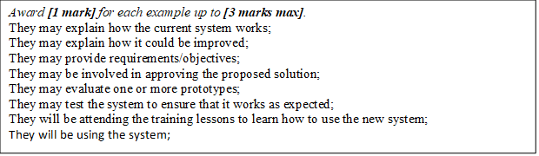Identify **three** examples of how employees, as users of the computer system,   
   may participate in the development of the new system. [3]
3. One method of conversion from the old computer system to the new computer   
   system is parallel running.
4. Define the term parallel running. [1]

Award [1 mark] for a correct definition.

The old system continues alongside the new system for a certain period of time;

1. Identify **one** other method of conversion. [1]

*Award* ***[1 mark]*** *for one method of conversion (other than parallel running) identified.*

Direct changeover;

Phased conversion;

Pilot conversion;

1. Compare parallel running with the method of conversion identified in part (ii). [4]

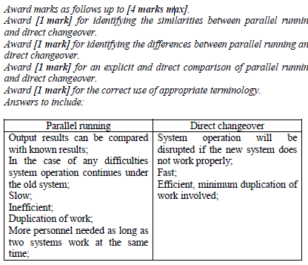

1. The data from the old computer system needs to be transferred onto the new [6]  
   computer system. Discuss **two** problems that may arise as a result of this data  
   migration.

*Award marks as follows up to* ***[6 marks max]****.*

*Award* ***[1 mark]*** *for each distinct problem identified, up to* ***[2 marks max]****.*

*Award* ***[1 mark]*** *for a description of each identified problem, up to* ***[2 marks max]****.*

*Award* ***[1 mark]*** *for an elaboration of the identified problems.*

*Award* ***[1 mark]*** *for correct terminology used throughout.*

*Answers may include:*

Incompatible formats of data: The new system may store data in a format different from that used in the old system. This might be a simple matter of translation, such as converting integers to decimals. It could also be very difficult if the new system stores more detailed data than the old system, such as the date and time of each transaction while the old system stored only the date.

Data lost in migration: Data might be lost due to errors in the translation process or because perfect translations simply are not possible, *e.g.* if the old system stored ratings on a scale of 1–5 while the new system stored only 1–3.

The systems may be unavailable during the migration process; one way to avoid having two systems with incompatible data is to shut down the business, perform the migration, and then restart with the new system. If the migration takes a long time however, shutting down the business for that time may be undesirable.

New data may continue coming in during the migration process; if the business is not shut down during the migration process, transactions will either have to be performed on the new system without the old data being available or they will have to be performed on the old system which will add to the data needing to be migrated.

|  |  |  |  |
| --- | --- | --- | --- |
| **Question 2** | | | |
| Objectives: | 1.7 | Exam Reference: | May-14 Question 2 |

Explain what is meant by beta testing. [2]

Testing prior to product’s full release / last stage of testing;

To see if it works properly / complete functionality / usability;

Performed by end users (not by designers);

|  |  |  |  |
| --- | --- | --- | --- |
| **Question 3** | | | |
| Objectives: | 1.1.13 | Exam Reference: | Nov-14 Question 2 |

Identify **two** methods that can be used to prevent data loss. [2]

*Award* ***[1 mark]*** *for each method identified up to* ***[2 marks max]****.*

Failover systems;

Redundancy;

Removable media;

Offsite / online storage;